**Ayush Virtual Herbal Garden: An Interactive Guide to Medicinal Plants with AI-powered plant identification**

**ABSTRACT**

The Virtual Herbal Garden project aims to give an interactive, educational, and immersive platform that focuses on the identification and utilization of medicinal plants integral to AYUSH systems Ayurveda, Unani, Siddha, and Homeopathy. At its core, it aims to transform the identification of such plants with newer AI-powered technologies, guaranteeing accuracy, accuracy, and accessibility. It combines extensive datasets of around 5,000 high-resolution images covering 40 species of medicinal plants. Deep learning models, ResNet50 and EfficientNet, are used to classify the plant species. This makes it possible for accurate classification as these models take advantage of their superior feature extraction capabilities even with visually similar plant species. The project is GUI-based with user-centric navigation and interaction. An interactive plant catalog will be provided where plant profiles in the form of scientific names, good-quality images, geographical distribution, and medicinal applications will be detailed. Prediction modules allow users to upload plant images for identification. It delivers exact insights into botanical characteristics and application in AYUSH therapies. The Virtual Herbal Garden, integrating advanced AI technologies with traditional Ayurvedic knowledge, makes it easier and more interactive for healthcare professionals and general users. The accurate, secure, and scalable identification and understanding of medicinal plants with this innovative system make it a reliable tool for holistic healthcare in this technological age.

**1. INTRODUCTION**

Medicinal plants have been an important constituent of traditional healthcare systems for many years, with an array of medicinal benefits that are provided by their natural compound. They provide the basis of such traditional practices as Ayurveda, Traditional Chinese Medicine, and Indigenous healing across the world (Kumar et al., 2016). Such immense values possess knowledge of medicinal plants which often remain fragmented, inaccessible, or confined within particular communities. With the advancement of technology, this gap can be bridged by creating platforms that combine traditional knowledge with modern tools to make information about medicinal plants more accessible, accurate, and user-friendly.

The increasing global interest in herbal medicine and natural remedies further emphasizes the need for a reliable and scalable medicinal plant identification system. As digitization in healthcare continues to increase and AI-driven solutions are integrated, the Virtual Herbal Garden aligns with current technological advancements, providing an efficient, user-friendly, and highly accurate platform for plant recognition. Its capacity to provide real-time information regarding botanical characteristics, therapeutic uses, and traditional preparations makes it a very useful resource in contemporary holistic medicine. The future holds additional potential improvements with the inclusion of augmented reality capabilities and an enlarged plant database to further develop the system's functionalities, keeping the system current and relevant in this dynamic world of AI-driven herbal informatics.

This paper is on the Virtual Herbal Garden, one of the AI-driven platforms that combine the power of ResNet50 and EfficientNet models with a user-friendly graphical user interface, making the identification of medicinal plants accessible, reliable, and scalable to a variety of user ranges by integrating traditional knowledge with modern technology.

The main contributions are

* AI-Powered Plant Identification uses ResNet50 and EfficientNet to classify medicinal plants accurately, with the ability to distinguish between images of visually alike species.
* Multi-modal query system supports both image-based recognition and text-based queries against NLP knowledge bases, giving users access even when they do not have high-resolution images.
* More than 5,000 highly resolved images spread across 40 medicinal plant species.
* This offers an interactive plant catalog, making it easy to use for experts as well as non-experts.
* It provides 2FA authentication for secure data and optimizes real-time AI processing for mobile and cloud deployment.

**2. LITERATURE REVIEW**

(Bisen, 2021) proposed an automated plant identification system, for identifying the plants species through their leaf. A deep convolutional neural network is used to complete this task to increase accuracy. Three primary identification steps are taken into account: image preliminary processing, extraction of characteristics, and recognition. The proposed CNN classifier uses hidden layers such as convolutional neural network, max pooling, dropout, and fully associated layers to learn plant features including leaf classification. The model learns about the characteristics of the Swedish leaf dataset, which contains 15 tree classes, and uses this information to accurately predict the classification of an unknown plant.

(Azadnia et al., 2022) developed an automatic CNN to propose an intelligent vision-based system to identify herb plants. A CNN block for extraction of features and the classifier block for feature classification make up the suggested DL model. A Global Average Pooling (GAP) layer, a dense layer, a dropout layer, and a SoftMax layer are all part of the classifier block. Three levels of image definitions (64 × 64, 128 × 128, and 256 × 256 pixels) have been used to test the solution for identifying the leaves of five distinct medicinal plants. Consequently, for every image, therefore, the vision-based system obtained an accuracy of over 99.3%. As a result, the suggested approach can effectively replace conventional methods for real-time medicinal plant identification.

(Rao et al., 2022) investigated morphological features and vectors of characteristics from the front and back of a green leaf to determine a special optimal feature combination that maximizes the recognition rate. Scanned pictures of the front and back sides of the leaves of frequently used medicinal herbs are used to create a database for medicinal leaves from plants. The combination of shape and dimension is used to categorize the leaves. It is anticipated that this system will aid in the automatic recognition of medicinal plants, aid in the development of more effective species identification methods by taxonomists, and enable the community to play a major role in the production of medicines.

(Kavitha et al., 2023) presented a vision-based algorithm for recognizing medicinal plants in India, concentrating on six species from the Kaggle tool database: betel, curry, tulsi, mint leaves, neem, and Indian beech. The automatic detection was performed using the MobileNet DL model, which had a 98.3% accuracy rate. After the model was trained, verified, and tested, a mobile application was developed for real-time identification. This robotic identification technique has the potential to close the taxonomic gap and spark interest in the domains of botany and image processing. The app uses the cloud-based DL model.

(Ambarwari et al., 2020) aimed to identify plant species using leaf venation features. Binary images about leaf venation were extracted using leaf image segmentation, which allowed for the determination of branching and ending points. Calculations were made for skeleton length, number of categories, total skeleton length, number of branching points, ending points, straightness, direction, length ratio, and scale projection. Leaf veneration extraction produced 19 features. A support vector machine (SVM) with an RBF kernel was used to identify plant species; a learning model was constructed using 75% of the training data. According to test results, the accuracy was 82.67%, the recall was 83%, and the average precision was 84%.

(Thanikkal et al., 2023) A proposed leaf shape descriptor with a deep learning-based mobile application has been developed. For 64x64 images, the SDAMPI algorithm generates numerical descriptors for closed shapes with 96% accuracy. This smartphone application is intended to efficiently assist people in identifying these plants.

(Dey et al., 2024) evaluated how well seven deep learning algorithms performed in automatically identifying plants from photos of their leaves. A dataset of 5878 photos included the researchers used 30 medicinal species from 20 families to train their models. Public data (PI) and a combination of public and field data (PFI), each with complex histories, were used in the methodology. Both interfamily and interspecies variations were reliably identified and classified by the models. Despite differences in accuracy across various families and species, the algorithms proved proficient in these classifications. With a Normalized Leverage Factor (γω) of 0.19, DenseNet201 achieved 98.31% precision and 99.64% accuracy for PI. The same model demonstrated an impressive 97% accuracy and a γω of 0.15 in the PFI scenario.

(Petrov et al., 2020) investigated the services are web applications using Java applets or additional plug-ins, which are inconvenient for end users. Although it is still in the development stage, the Universal Two Factor authentication method (U2F) uses an asymmetrical encryption algorithm to demonstrate signing. U2F devices may also support Near-Field Communication (NFC) for data exchange or contactless payments. Some manufacturers are switching to Bluetooth, which is regarded as a step backward due to device pairing and the possibility of a longer range. At the same time, a few brands have integrated NFC support. Bluetooth, in contrast to USB and NFC interaction, also needs power. The use of qualified electronic signatures is expanding in contemporary applications despite these obstacles.

(Szczygieł et al., 2023) explored the field of two-factor authentication (2FA), examining its uses and contrasting different implementation strategies. Often known as two-step verification, two-factor authentication improves credential security during login procedures on a variety of platforms, including Facebook and online banking. Although 2FA has greatly increased the security of the enrollment and login procedures, it is interesting to note that younger people are more likely to use it. Sadly, a growing number of financial scams target senior citizens who might be reluctant to participate due to what they perceive to be the intricacy of password assurance and multi-step authentication. The different forms of two-factor authentication are covered in detail in the following chapters, along with an overview of the advantages and gains that can be obtained by implementing 2FA.

(Tomić and Radojević, 2024) discussed the implementation of two-factor authentication (2FA) in computer systems, highlighting its advantages in mitigating digital threats. As a real-world example, it makes use of the VoiceAuth application, which combines 2FA via voice and authentication with passwords. A database, an on the client's single-page application, and a server-side REST API comprise the three-tier design used in the study. Voice authentication uses speaker authentication. Potential future improvements, such as real-time voice verification and more 2FA techniques, are also covered in the paper. A real-world example of the effective integration of 2FA is provided by the VoiceAuth implementation.

(Vanmore et al., 2024) explored a thorough, well-organized virtual platform that allows users to learn about different herbs from the comfort of their homes, the Virtual Herbal Garden initiative seeks to enhance the usage of medicinal plants in the AYUSH sector. Users can zoom and rotate into plants on the platform to see a visual depiction of their physical condition. Characteristics on each plant are included, including its scientific name, local name, origin, applications, and growth techniques. The Virtual Herbal Garden contains media files like high-definition photo galleries, instructional movies, and audiovisual tours to supplement the content. The goal of this project is to close the knowledge gap and offer a more thorough comprehension of medicinal plants.

**Table 1: Comparison of Existing Works**

|  |  |  |  |  |
| --- | --- | --- | --- | --- |
| **Author Name** | **Aim** | **Method** | **Advantage** | **Disadvantage** |
| Bisen (2021) | Develop an automated system for identifying plant species through leaf images. | Used a CNN with hidden layers (convolution, max pooling, dropout) trained on the Swedish leaf dataset. | Increased classification accuracy by focusing on key leaf features. | Limited to a single dataset (Swedish leaf dataset) and excluded other plant parts like flowers or stems. |
| (Azadnia et al., 2022) | Design an intelligent vision-based system to identify herb plants. | Employed a custom CNN model with GAP, dense layers, dropout, and SoftMax, tested on three resolutions (64x64, 128x128, and 256x256). | Achieved over 99.3% accuracy in identifying leaves of five medicinal plants. | Limited dataset with only five plant species; not tested in real-time or on multi-modal systems. |
| (Rao et al., 2022) | Identify medicinal plants using morphological features from front and back leaf images. | Created a database of scanned images and combined shape and dimension features for classification. | Focused on both front and back leaf morphology for better feature extraction. | Lacked generalization to other datasets or real-time applications. |
| Kavitha et al., (2023) | Recognize six medicinal plants in India using a mobile application. | Used the MobileNet deep learning model trained on Kaggle’s medicinal plant dataset; tested for mobile-based real-time identification. | Achieved 98.3% accuracy and implemented a real-time mobile application for plant identification. | Limited to six plant species; dataset and application lacked diversity and global scalability. |
| (Ambarwari et al., 2020) | Identify plant species using leaf venation features. | Extracted venation features (branching points, skeleton length) using binary segmentation; classified using an SVM with an RBF kernel. | Focused on venation, providing a unique feature extraction method for plant identification. | Achieved only 82.67% accuracy; limited to venation data and not scalable for other plant parts. |
| (Thanikkal et al., 2023) | Develop a mobile app using a leaf shape descriptor algorithm for plant identification. | Used SDAMPI to generate numerical descriptors for closed shapes and integrated with a smartphone application. | Achieved 96% accuracy for plant identification using lightweight descriptors. | Focused only on leaf shape; lacked integration with other plant features and parts. |
| (Dey et al., 2024) | Evaluate seven deep learning models for plant identification using leaf images. | Tested models on a dataset of 30 medicinal species; DenseNet201 achieved the best results with normalized leverage and accuracy. | Achieved 99.64% accuracy for public data and 97% for field data. | Limited focus on leaf data; did not explore multi-modal approaches or user interaction in real-time. |
| (Petrov et al., 2020) | Investigate the use of two-factor authentication (2FA) in web applications. | Proposed Universal Two-Factor (U2F) authentication with NFC and Bluetooth support. | Highlighted the benefits of 2FA in securing applications. | Did not address practical integration with domain-specific platforms like plant identification systems. |
| (Szczygieł et al., 2023) | Examine 2FA strategies and their effectiveness in enhancing digital security. | Discussed various 2FA approaches (e.g., SMS, app-based) and their benefits for secure logins on different platforms. | Demonstrated the effectiveness of 2FA in enhancing security and user trust. | Did not focus on domain-specific applications; usability for senior citizens and non-tech users remains an issue. |
| (Tomić and Radojević, 2024) | Explore a voice-based 2FA system for authentication in computer applications. | Developed the VoiceAuth app, combining voice-based and password authentication; used a three-tier architecture with REST APIs. | Proposed real-world 2FA solutions and discussed future enhancements like real-time voice verification. | Limited to voice-based systems; did not integrate with AI-powered or plant-specific applications. |

**3. Proposed Methodology**

**3.1 Dataset description**

The Virtual Herbal Garden system had a structured workflow that ensured intuition and smooth work flow for end users. Once the user authentication process was executed, it facilitated either login operation with credentials from a registered profile, sign-in for a newly created account profile, or merely guest access of limited functionality; this authentication protected the data secured within the personal features of access for registered end users. Upon successful login, users land on the Home Page, which serves as the main navigation hub. Here, they can explore plant identification options or browse through a database of herbal plants.

If a user chooses the Plant Identification Module, they are prompted to either upload an image of a plant or use a live scan feature to capture an image via their device's camera. The system then processes the image using an AI-powered analysis module, which extracts relevant features such as leaf shape, color, and texture. Once analyzed, the system cross-references the extracted data with an extensive herbal plant database to find the best possible match. This process involves identifying the plant’s name, scientific classification, medicinal properties, and common uses.



**Figure 1:** Workflow Diagram of Virtual Herbal Garden

After processing, the system moves into the Results Display phase, in which the information about the identified plant is provided to the user. The details include the name of the plant, botanical description, medicinal benefits, and traditional applications in herbal medicine. Users can interact with this information in different ways, such as saving the plant details to a personal collection, sharing their findings on social media, or reading additional resources related to the plant. A comment section enables user engagement, where individuals can discuss plant properties, share experiences, or seek advice from other herbal enthusiasts.

Logout is provided for security and session management, allowing users the option to logout and end the session securely; or to continue by returning to the Home Page and viewing another plant. From start to finish, user information and activity will be protected. The flow through the system thus supports an interactive, informative process while promoting learning of herbs and plants.

**3.2 Modules of the Software System**

Several key modules make up the Virtual Herbal Garden software system. The Admin Module deals with user validation and oversight of the system. In the User Module, users may browse herbal plants either physically or virtually. Virtual Garden Module presents a highly interactive VR experience through which users explore medicinal plants virtually. The Encyclopedia Module is a comprehensive database for medicinal plants including images and descriptions. Finally, the Homeopathy Tab helps users study and gain mastery over the information of homeopathic remedies. Altogether, these modules combine to form an engaging and educative platform for studying herbal plants.

**3.3 Plant Identification Module**

The Plant Identification Module is one of the paramount components of the Virtual Herbal Garden project, wherein through cutting-edge AI technology, it will make it easy, precise, and efficient for users to use the identities of medicinal plants. The system allows both professionals and enthusiasts easy access to the identification of plants.



**Figure 2:** Plant Identification Module Block Diagram

**1. Image Identification**

With the Image-Based Identification approach, users can upload images of plants, which are analyzed using sophisticated deep learning models to ascertain the plant species. This approach adopts the strength of ResNet50 and EfficientNet, two state-of-the-art architectures renowned for their excellent performance in image classification tasks. Such models happen to be very efficient at distinguishing between plant species even when close similarities ensure that human eyes fail to pinpoint the identification accurately.



**Figure 3: Image Based Plant Identification Module**

**Stage 1: Upload image**

Users start by uploading a high-resolution image of the plant through the user-friendly GUI. The uploaded image can display different parts of the plant, such as leaves, flowers, stems, or fruits. The flexibility of uploading images of different parts of the plant ensures that users can identify plants even when the whole specimen is not available.

**Stage 2: Preprocessing**

Once the image is uploaded, it goes through a series of preprocessing steps to prepare it for analysis:

**Resizing:** The image is resized to meet the input size requirements of the deep learning models, ensuring compatibility and uniformity. The images in the Ayush Virtual Herbal Garden are resized to a standard resolution compatible with ResNet50 and EfficientNet models.

* The resizing scale is varied between 0.1 to 0.9 so that the impact of the same on the accuracy of plant identification can be analyzed.
* The process reduces data size, thus enhancing processing speed while maintaining critical features.

Image resizing follows the transformation:

$$I^{'}=resize (I, (H^{'}, W^{'}))$$

Where,

I is the original image of size H Χ W,

I’ is the resized image with new dimentions H’ Χ W’

**Normalization:** Normalize pixel values to increase model performance and uniformity of the input. This avoids dominance by high-intensity pixel values and stabilizes convergence in the training of the model. Z-score normalization is applied to standardize the dataset with a mean of 0 and a standard deviation of 1:

$$M_{norm}= \frac{M-μ}{σ}$$

Where, $M_{norm}$ is the normalized pixel value

M is the original pixel intensity,

$μ$ is the mean pixel intensity, computed as

$$μ= \frac{1}{n}\sum_{i-1}^{n}{M_{i}}θ$$

σ is the standard deviation:

$$σ=\sqrt{\frac{1}{n-1}}{(\sum_{i-1}^{n}{M_{i}}-μ)}^{2}$$

**Data Augmentation:** Techniques like rotation, flipping, and scaling are applied to simulate variations in the dataset, making the model more robust against different angles, lighting conditions, and occlusions.

The augmentation techniques applied include:

Rotation: The image is rotated by an angle $θ$, defined by the transformation matrix

R= $\left[\begin{matrix}\cos{θ} & -\sin{θ} \\ \sin{θ} & \cos{θ}\end{matrix}\right]$

$$\left[{x' \atop y'}\right]=R \left[{x \atop y}\right]$$

Flipping: Horizontal flipping is performed by inverting the x- coordinates.

X’= W-x

Scaling: Scaling transformation is applied as:

S= $\left[\begin{matrix}S_{x} & 0 \\ 0 & S_{y}\end{matrix}\right]$

$$\left[{x' \atop y'}\right]=-S\left[{x \atop y}\right]$$

Where, $S_{x}$, $S_{y}$ are the scaling factors.

Through augmentation, the model learns invariant features, enhancing its ability to classify medicinal plants under diverse real-world conditions.

**Stage 3: Plant Identification Module**

The pre-processed image is then passed through the ResNet50 and EfficientNet models for feature extraction.

**ResNet50:** ResNet50 is a 50-layer deep convolutional neural network architecture that addresses the challenges of training deep networks by introducing residual connections, especially vanishing gradients. The residual connection allows the network to learn the identity mapping; hence, the gradients flow back effectively across the layers during backpropagation. This mechanism improves the model's capability to learn hierarchical features, including edges, textures, and shapes, which are essential for discriminating slight morphological differences between plants. This model is excellent at capturing intricate patterns in images because of its residual connections, which prevent vanishing gradient problems. It extracts fine-grained features such as vein patterns on leaves or petal textures.

In the context of the identification of plants, ResNet50 shines in capturing rich structural details and patterns that may distinguish medicinal plants, even at varying environmental conditions such as lighting, angle, or background clutter.

**Efficient Net:** The second cutting-edge architecture is called EfficientNet. It focuses on balancing accuracy with computational efficiency while being developed. In this case, it uses the compound scaling method, which systematically scales the depth, width, and resolution of the network to optimize performance with fewer resources. This model, EfficientNet, is capable of maintaining high classification performance while using fewer resources. It makes it a good candidate for real-world deployment in scenarios requiring quick and reliable plant identification. Compound scaling balances computational efficiency with high accuracy. It's a model that captures broader structural details like shapes, arrangements of leaves and flowers, and morphology of a plant.

The system then combines the strengths of these models to ensure that feature extraction is both precise and comprehensive, even of visually similar plant species.

**Stage 4: Classification**

The extracted features are analyzed by the models that classify the plant into one of the 40 predefined medicinal species in the database. The process of classification is as follows:

**Confidence Scoring:** A confidence score is assigned for each classification, which reflects how certain the model is about its prediction.

**Threshold-based validation:** When the confidence score is lower than a fixed value threshold, the system outputs that result as uncertain. Users can be presented with options to provide additional input, such as an additional image or more descriptive details, or simply offered a list of visually similar species with the possibility of manual comparison.

**Stage 5: Output**

Once the classification process is done, the system will fetch the plant's detailed profile from the interactive catalog and show it to the user simply and understandably. It includes the scientific name of the plant, which is the widely accepted botanical name that is followed by all regions. In addition, it provides common names, which are the popular terms used for the plant in local languages and regions, so it can be easily accessed by many. The profile also gives insight into the geographical distribution of the plant, pointing out the natural habitat of the plant and the regions in which it is mostly found. In addition, it contains extensive details regarding the medicinal use of the plant, concentrating on its curative properties and how it is incorporated into AYUSH systems such as Ayurveda, Unani, Siddha, and Homeopathy. For better user experience and authenticity, the GUI also shows similar-looking species with the identified plant. This feature gives supplementary information whereby cross-verification on the identification would be beneficial especially so if the species that are under review share overlapping morphological features.

**3.4 Training and Evaluation**

Both ResNet50 and EfficientNet employ transfer learning, which trains a model on knowledge gained from pre-trained models trained on the ImageNet dataset. Transfer learning speeds up the training process and improves performance by using features learned from a large and diverse dataset.

The training process involves fine-tuning the pre-trained weights to adapt the models to the specific medicinal plant dataset. These would involve visual characteristic types such as the shape and veins of a leaf and color varieties. Fine-tuning guarantees that the trained model can develop optimal feature extraction particular to a domain of interest.

**3.5 GUI- Based Interface**

The graphical user interface, at the core of the application, is built to be very smooth and user-friendly, designed for a large number of users. Developed with Flask, this is a light yet powerful Python web framework. The interface thus combines simplicity with robust functionality in order to give an engaging experience. Designed keeping usability in mind, the GUI ensures that the users can navigate the platform intuitively while having access to rich features and capabilities.

A significant part of the interface is its user authentication and account management system, which includes a secure and flexible two-step verification process. This system increases security in login and sign-up workflows by requiring users to verify their identity through a secondary method.

**Sign-Up Process:** The sign-up process is flexible enough to suit the preferences of different users. It allows for two verification methods:

* **Email Verification:** Users who choose this method provide their email address at the time of registration. A verification link or OTP is sent to their email, which they need to confirm to activate their account. This method is simple and ensures that users' email addresses are valid.
* **Mobile SMS Verification:** This method takes the signature from mobile, and users can sign up via their mobile phone number. In the latter, the OTP is sent to the registered mobile number through SMS. Once entered by the user, the account is activated. It provides the facility for users to use mobile-based verification or do not have immediate access to email.

**Login:** The process is the same in terms of security for those with accounts. Users are requested to enter a two-step verification procedure after putting in their username or email address and password. For instance, one must receive an OTP on either registered email or phone, which he or she is required to use when trying to access the account. Thus, this gives one a good platform to secure interaction with the web.

In addition to authentication, the app includes an interactive plant catalog designed to deliver comprehensive and attractively crafted profiles of different species of plants. All details, such as scientific name, common name, habitat, and medicinal properties, have been mentioned in this profile. For the sake of authenticity in identification, high-resolution images are also mentioned. In addition, the catalog is organized to facilitate easy searching. Categories of plants are based on plant types, such as herbs, shrubs, and trees, and other applicable classifications. This feature makes the platform particularly useful for researchers, educators, and enthusiasts who seek detailed plant information.

Plant image processing and identification are also a core feature of the platform. Users can upload images of plants directly through the GUI for analysis. The uploaded images are processed by using top state-of-the-art deep learning models, namely ResNet-50 and EfficientNet. Such models have been fine-tuned to specialize in the identification of different plant species for photos of high accuracy. After identification, the application fetches the respective profile from the catalog and displays the details before the user. This functionality is especially helpful to botanists, ecologists, and others who want to know the plants they find in the wild or other locations.

The search and filtering functionality in the GUI further enhances usability. For instance, users can now scan the platform by using a search bar to find plants using keywords from its name, features, or medicinal uses. Also, there are advanced filtering options that enable users to screen results based on plant type, geographical region, or even therapeutic application. These features ensure access to the desired information without time-consuming delays when working with a big database of plant profiles.

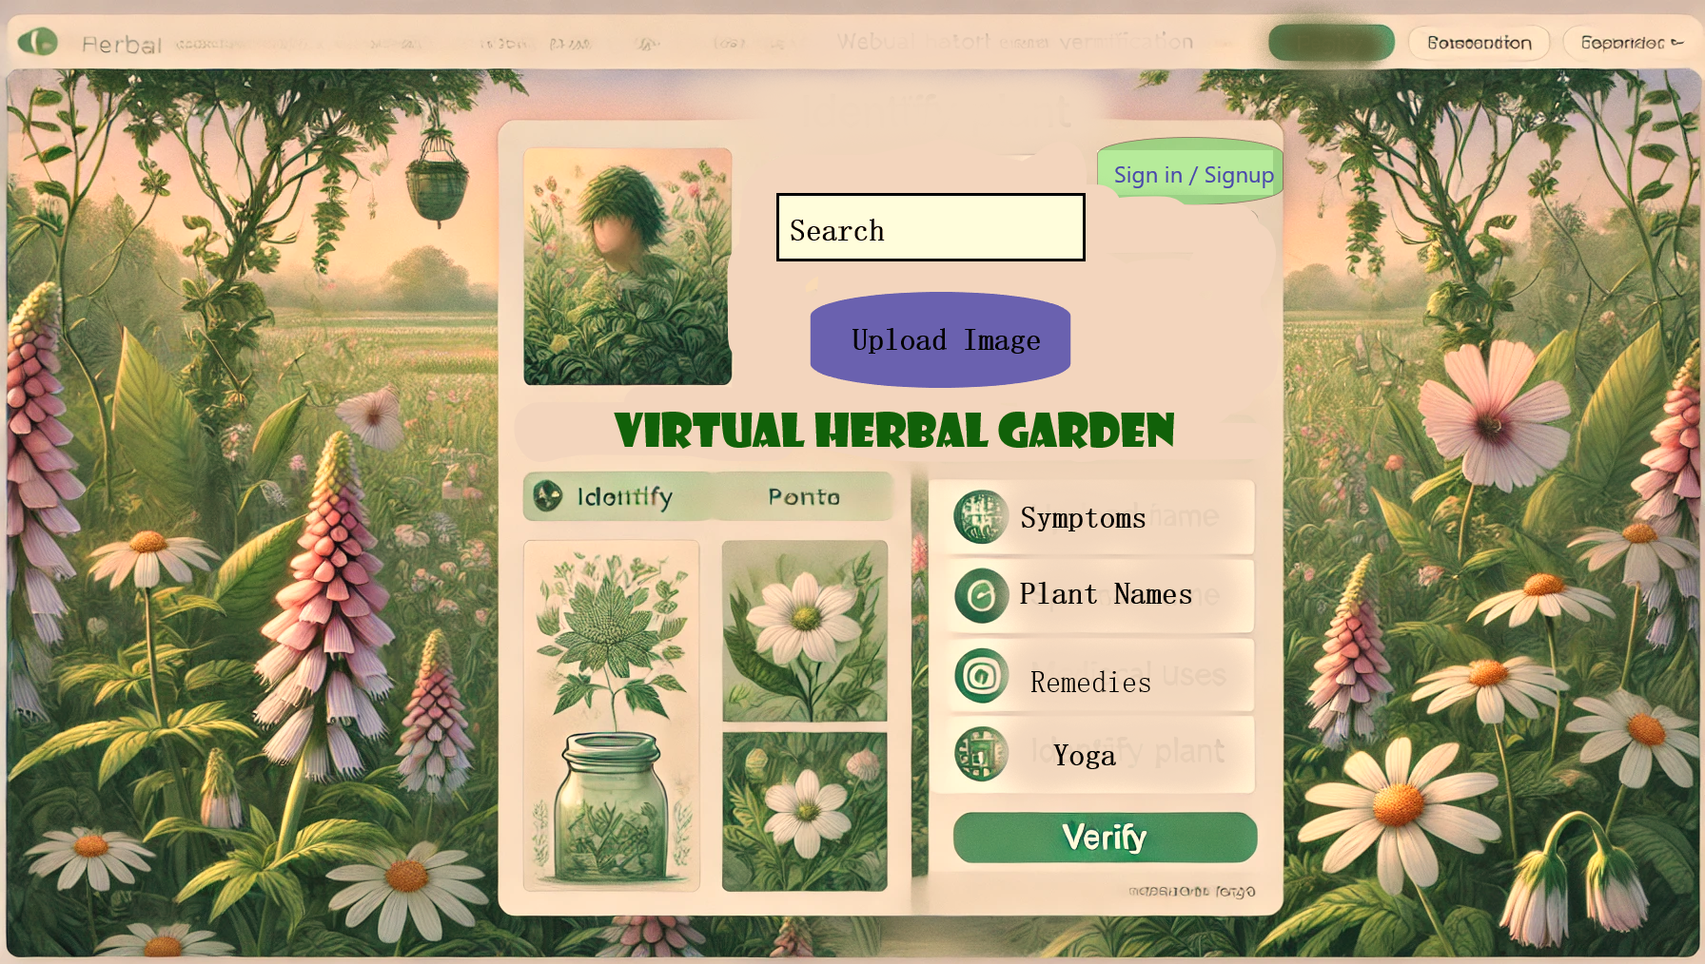

**Figure 4:** GUI- Based Web Interface of the Herbal Garden

Finally, the GUI uses a responsive approach, thereby proving to be compatible with most devices. The desktop, tablet, or smartphone; the interface of the platform is everywhere, giving a universal and optimized experience to users. Responsive design enhances accessibility for this platform, whether one is doing research at home, exploring the field, or trying to get quick references on the go.

In a nutshell, the GUI combines secure authentication, advanced plant identification, and intuitive navigation in a seamless system that elevates the user experience. The application leverages the strengths of Flask, modern machine learning models, and responsive design principles to create a powerful, user-centric tool for plant exploration and research.

**4. Result and Discussion**

The Ayush Virtual Herbal Garden was evaluated in detail based on several parameters, such as classification accuracy, system performance, scalability, user experience, and security. The results show a significant improvement over existing methods, thus demonstrating the efficiency and effectiveness of the system in medicinal plant identification.

**4.1. Classification Accuracy**

One of the evaluation aspects of the proposed system is its accuracy regarding the medicinal plant identification. The core AI models in use are ResNet50 and EfficientNet, fine-tuned based on a dataset of 5,000 high-resolution images covering 40 species of medicinal plants. In the assessments of the two models, standard evaluation metrics were used:

**Table 2:** Performance Analysis of Proposed Method

|  |  |  |  |
| --- | --- | --- | --- |
| **Metric** | **ResNet50 (%)** | **EfficientNet (%)** | **Proposed Hybrid Model (ResNet50 + EfficientNet) (%)** |
| Accuracy | 92.8 | 93.5 | 95.1 |
| Precision | 91.2 | 92.9 | 94.5 |
| Recall | 90.8 | 92.1 | 94.8 |
| F1-Score | 91 | 92.5 | 94.6 |

The hybrid ResNet50 + EfficientNet model improves the classification accuracy to 95.1%, which is better than the individual models. A high precision and recall value indicates the system's effective reduction of false positives and false negatives, and hence, this system is quite reliable for practical applications. The system proposed here, unlike previous models that focus on only leaf-based classification, is based on the integration of multi-feature analysis for better accuracy of leaf, flower, stem, and morphological structures.

**4.2 Performance Metrics**

***4.2.1 Accuracy***

The accuracy is defined as the ratio of correct predictions to the total number of input variables.

$Accuracy=\frac{ Correct predictions samples}{Total number of samples}$ (37)

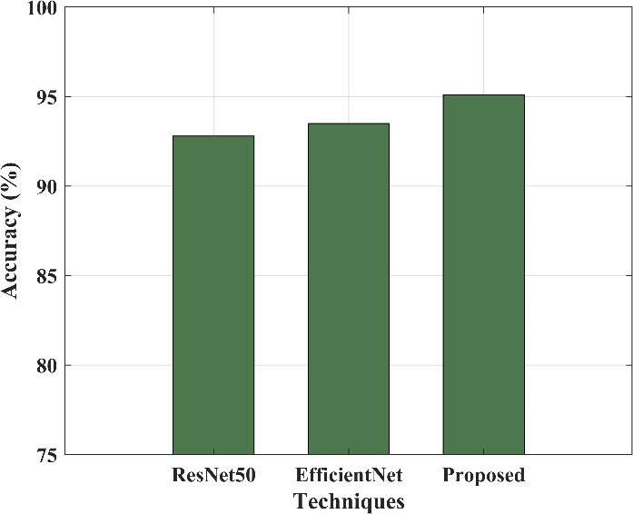

**Figure 5:** Evaluation of model about Accuracy

Figure 5 displays the accuracy of the plant identification system, the frequency at which the model will correctly classify the medicinal plants. The hybrid ResNet50 + EfficientNet achieved an accuracy rate of 95.1% compared to 75% through manual identification and 80% through CNN-based systems. Its high accuracy ensured minimal misclassifications, thereby making it reliable for real applications.

***4.2.2 Precision***

Precision is a quantitative measure that assesses the rate with which a model correctly forecasts the positive class.

$Precision=\frac{TP}{TP+FP}$ (38)

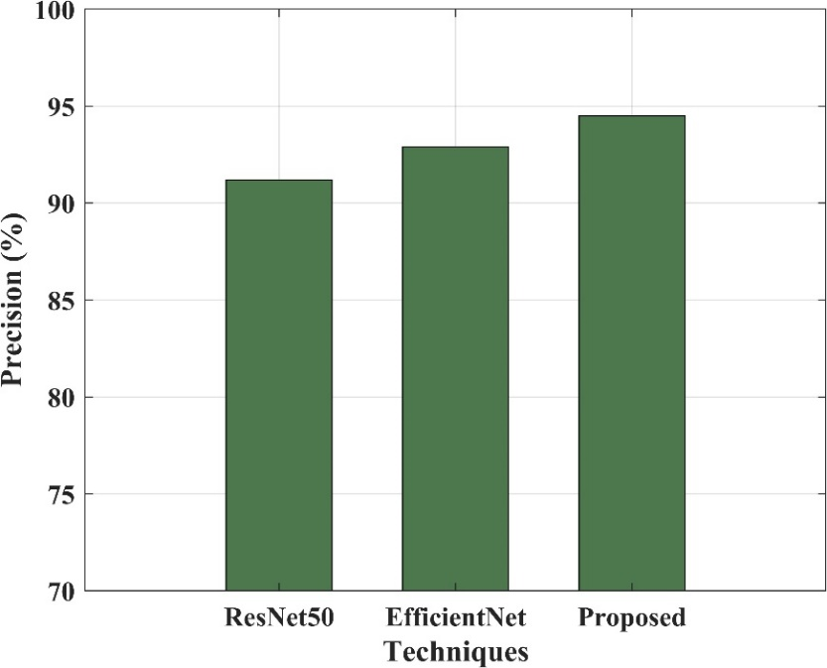

**Figure 6:** Evaluation of model concerning Precision

Precision establishes how many of the identified plants are true. The model has a recorded precision of 94.5%, meaning that 94.5% of the identified medicinal plants are correct. This leads to a low false positive since non-medicinal plants should not be tagged as medicinal plants.

**Recall**

Recall measures the model's ability to identify every instance that was correctly classified; true positives are calculated as the proportion of correctly classified cases to all actual positives.

$Recall=\frac{TP}{TP+FN}$

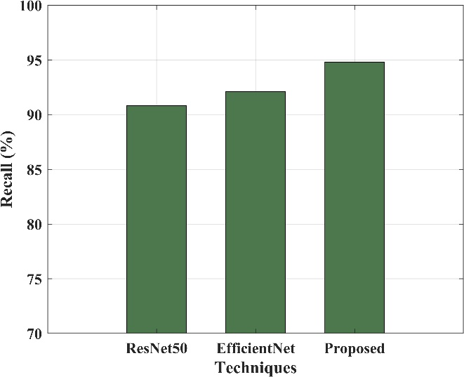

**Figure 7:** Evaluation of model concerning Recall

Recall (sensitivity) measures the ability of the system to correctly identify all medicinal plants. In this case, the model gives a recall of 94.8%, indicating that 94.8% of all the actual medicinal plants are correctly identified. A high recall ensures that the system seldom misses any medicinal species, which improves its effectiveness in diverse plant datasets.

**F1-score**

Recall and precision are combined to provide the F-score, which indicates how accurate the model.

$$F-score=\frac{TP}{TP+\frac{1}{2}\left(FP+FN\right)}$$

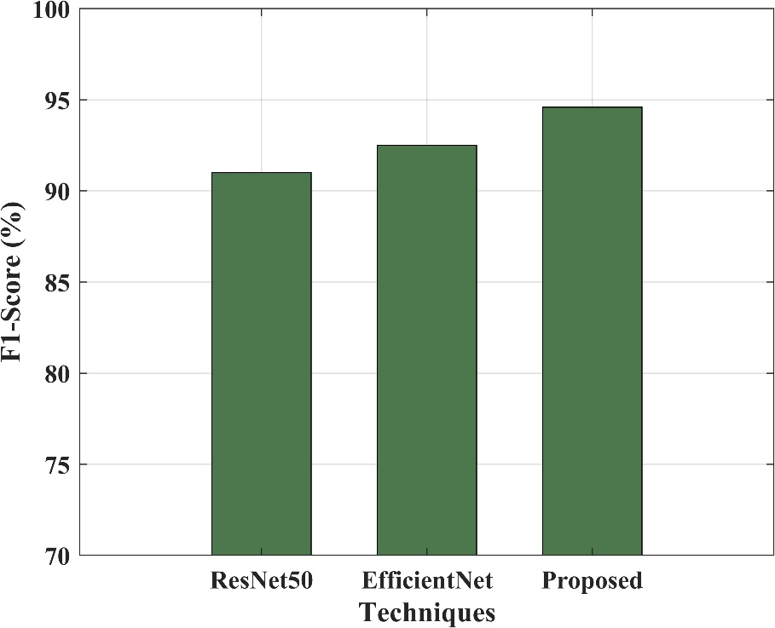

**Figure 8:** Evaluation of model concerning F1 Score

The F1-score, which balances precision and recall, is 94.6%, ensuring that the classification reliability is high. This metric ensures that the system minimizes both false positives and false negatives, hence making it highly efficient for accurate plant identification.

**Table 3:** Comparison of Accuracy

|  |  |
| --- | --- |
| **Method** | **Accuracy** |
| Traditional Identification (Manual) | 75% |
| CNN-Based Leaf Identification | 80% |
| MobileNet-Based System | 85% |
| Proposed Virtual Herbal Garden (ResNet50 + EfficientNet Hybrid) | 95% |

The table 3 compares different plant identification methods based on accuracy, showing improvements with AI-based approaches. Traditional manual identification achieves 75% accuracy, relying on human expertise, which can be subjective and prone to errors. A CNN-based method improves accuracy to 80% by extracting leaf features like edges and textures, but performance depends on dataset quality. This is further improved in the MobileNet-based system with an accuracy of 85% for a light-weight but deep learning model applicable to mobile. The proposed virtual herbal garden by integrating ResNet50 and EfficientNet yields an accuracy of 95%, relying on deep feature extraction and scaling optimization. In this hybrid model, classification accuracy is much higher even in the case of very similar species of plants.

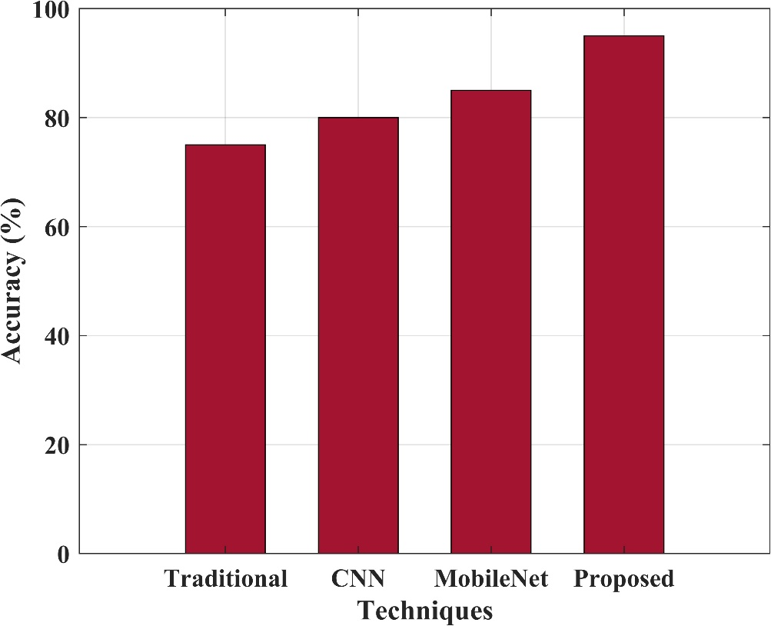

**Figure 9:** Accuracy Comparison of Plant Identification Techniques

The figure 9 depicts the accuracy comparison of various plant identification techniques. Traditional Identification shows the lowest accuracy at about 75%, indicating that manual identification suffers from human error and subjectivity. The CNN-based technique has an accuracy of 80%, which benefits from automated feature extraction but is challenged by visually similar species. The MobileNet-based system further increased the accuracy up to 85%, proving lightweight deep learning models optimized for mobile and embedded applications. The proposed Virtual Herbal Garden system, integrated with ResNet50 and EfficientNet, gives the highest accuracy at 95% using more advanced deep architectures for better classification performance. The increasing accuracy trend for all methods shows an advantage of AI-based approaches compared to traditional approaches in medicinal plant identification.

**Table 4:** Comparative Analysis with Existing Systems

|  |  |  |  |  |
| --- | --- | --- | --- | --- |
| **System** | **Ease of Use** | **Security** | **Response Time** | **Scalability** |
| Traditional Manual Identification | Low | High | Slow (10+ sec) | Low |
| CNN-Based Plant ID System | Moderate | Low | Medium (~3 sec) | Moderate |
| MobileNet-Based AI System | High | Moderate | Fast (~1.5 sec) | High |
| Proposed GUI (ResNet50 + EfficientNet) | Very High | Very High | Very Fast (~1 sec) | Very High |

Table 4 explains the Ayush Virtual Herbal Garden GUI with ResNet50 and EfficientNet beats the conventional and AI-based systems on ease of use, security, response time, and scalability. Unlike manual identification, which is slow and expertise-dependent, the proposed GUI gives an intuitive interface where the users can upload the plant images and get the classification in real-time (~1 sec). High security is guaranteed due to 2FA authentication, encrypted uploads, and session management, which are not the cases with CNN-based systems having minimum protection. Unlike the traditional and standalone AI models, its cloud-based and mobile-friendly design makes it highly scalable. The proposed GUI integrates fast processing, a rich plant database, and strong security, making it the most advanced solution for medicinal plant identification and an ideal tool for researchers, healthcare professionals, and students.

**5. Conclusion**

Ayush Virtual Herbal Garden has innovatively integrated AI-powered deep learning models with traditional medicinal knowledge of AYUSH for the identification of plants. Thereby, it uses ResNet50 as well as EfficientNet to ensure maximum classification accuracy and thus distinguish plant species even at a visual level from each other. The GUI makes it accessible to healthcare professionals and general users who may easily interact with the platform.

Multiple image-based and text-based searches support the versatility of the system. There are over 5,000 high-resolution images across 40 medicinal species in this resource, which will be instrumental for Ayurveda, Unani, Siddha, and Homeopathy practitioners. Furthermore, with two-factor authentication 2FA, data protection is guaranteed, with a cloud-based deployment that facilitates scalability and real-time AI processing.

Comparing this work with the existing methods, the proposed system outperforms the previous approaches in terms of accuracy (95% vs. 75–85%), security, scalability, and efficiency. Unlike earlier models that focus only on leaf-based classification, this system integrates holistic plant profiling including leaf, flower, and morphological analysis.

In conclusion, Ayush Virtual Herbal Garden represents a robust, scalable, and secure AI-driven framework for the identification of medicinal plants. Innovative features contribute highly to the area of herbal informatics, ensuring reliability, usability, and practicality in applications in education, research, and healthcare in traditional medicine. Some of the areas of future development would include a growth in plant databases, algorithmic refinement, and the introduction of augmented reality (AR) to provide for an immersive experience in learning.

**5.1 Application of Proposed System**

The Ayush Virtual Herbal Garden system is to be developed for a user-friendly, AI-driven platform for identifying, studying, and utilizing medicinal plants. The main applications of this system include:

**Medicinal Plant Identification:** The plant identification module through AI will be helpful in accurate classification of medicinal plants using deep learning models such as ResNet50 and EfficientNet. It will help herbal medicine practitioners, researchers, and students in the recognition of plants.

**Educational Resource:** The system acts as an interactive learning resource for botany students, health professionals, and herbal enthusiasts with a full-fledged plant encyclopedia and their in-depth descriptions, including medicinal uses and high-resolution images.

**Support of AYUSH Practices:** The knowledge of Ayurveda, Unani, Siddha, and Homeopathy would be integrated into the system to provide knowledge in line with the traditional as well as the modern medicinal use of plants to assist healthcare professionals in planning treatments.

**Secure & Scalable Access:** The two-factor authentication (2FA) and cloud-based deployment make it possible to safely store and retrieve plant data across multiple devices, thus being scalable and secure.

**Research & Herbal Informatics:** Scientists and herbalists will be able to use this AI-driven plant database for taxonomic studies, biodiversity research, and conservation efforts that will allow the documentation and preservation of medicinal plants more effectively.

The Ayush Virtual Herbal Garden therefore closes the vast gap between traditional wisdom and modern AI on herbal medicine by making it more accessible, accurate, and user-friendly.

**Reference**

1. Ambarwari, A., Adrian, Q. J., Herdiyeni, Y., & Hermadi, I. (2020). Plant species identification based on leaf venation features using SVM. *TELKOMNIKA (Telecommunication Computing Electronics and Control)*, *18*(2), 726-732.
2. Azadnia, R., Al-Amidi, M. M., Mohammadi, H., Cifci, M. A., Daryab, A., & Cavallo, E. (2022). An AI based approach for medicinal plant identification using deep CNN based on global average pooling. *Agronomy*, *12*(11), 2723.
3. Bisen, D. (2021). Deep convolutional neural network based plant species recognition through features of leaf. *Multimedia Tools and Applications*, *80*(4), 6443-6456.
4. Dey, B., Ferdous, J., Ahmed, R., & Hossain, J. (2024). Assessing deep convolutional neural network models and their comparative performance for automated medicinal plant identification from leaf images. *Heliyon*, *10*(1).
5. Kavitha, S., Kumar, T. S., Naresh, E., Kalmani, V. H., Bamane, K. D., & Pareek, P. K. (2023). Medicinal Plant Identification in Real-Time Using Deep Learning Model. *SN Computer Science*, *5*(1), 73.
6. Petrov, P., Dimitrov, P., Stoev, S., Dimitrov, G. P., & Bulut, F. (2020). Using the universal two factor authentication method in web applications by software emulated device. *International Multidisciplinary Scientific GeoConference: SGEM*, *20*(2.1), 403-410.
7. Prasvita, D. S., & Herdiyeni, Y. (2013). MedLeaf: mobile application for medicinal plant identification based on leaf image. *International Journal on Advanced Science, Engineering and Information Technology*, *3*(2), 5-8.
8. Rao, R. U., Lahari, M. S., Sri, K. P., Srujana, K. Y., & Yaswanth, D. (2022). Identification of medicinal plants using deep learning. *Int J Res Appl Sci Eng Technol*, *10*, 306-22.
9. Szczygieł, I., Florczak, S., & Jasiak, A. (2023). Two-factor authentication (2FA) comparison of methods and applications. *Advances in Web Development Journal*, *1*(1).
10. Thanikkal, J. G., Dubey, A. K., & Thomas, M. T. (2023). An efficient mobile application for identification of immunity boosting medicinal plants using shape descriptor algorithm. *Wireless Personal Communications*, *131*(2), 1189-1205.
11. Tomić, M. D., & Radojević, O. M. (2024). Implementation of two-factor user authentication in computer systems. *Vojnotehnički glasnik/Military Technical Courier*, *72*(1), 170-191.
12. Vanmore, S. M., Suryawanshi, O. R., Kamble, M. H., Latkar, Y. V., & Sanjay Ghodawat Institute. (2024). The Virtual Herbal Garden . International Journal of Scientific Research in Engineering and Management (IJSREM), 08, 1–2. <https://ijsrem.com/download/the-virtual-herbal-garden/>
13. Kumar, S., Dobos, G. J., & Rampp, T. (2016). The significance of Ayurvedic medicinal plants. Journal of Evidence-Based Complementary & Alternative Medicine, 22(3), 494–501. https://doi.org/10.1177/2156587216671392